1. Principiul Open-Closed

This is the first of my Engineering Notebook columns for The C++ Report. The articles
that will appear in this column will focus on the use of C++ and OOD, and will address
issues of software engineering. I will strive for articles that are pragmatic and directly useful
to the software engineer in the trenches. In these articles I will make use of Booch’s
notation for documenting object oriented designs. The sidebar provides a brief lexicon of
Booch’s notation.
There are many heuristics associated with object oriented design. For example, “all
member variables should be private”, or “global variables should be avoided”, or “using
run time type identification (RTTI) is dangerous”. What is the source of these heuristics?
What makes them true? Are they always true? This column investigates the design principle
that underlies these heuristics -- the open-closed principle.
As Ivar Jacobson said: “All systems change during their life cycles. This must be
borne in mind when developing systems expected to last longer than the first version.”1
How can we create designs that are stable in the face of change and that will last longer
than the first version? Bertrand Meyer2 gave us guidance as long ago as 1988 when he
coined the now famous open-closed principle. To paraphrase him:
SOFTWARE ENTITIES (CLASSES, MODULES, FUNCTIONS, ETC.)
SHOULD BE OPEN FOR EXTENSION, BUT CLOSED FOR
MODIFICATION.
When a single change to a program results in a cascade of changes to dependent modules,
that program exhibits the undesirable attributes that we have come to associate with “bad”
design. The program becomes fragile, rigid, unpredictable and unreusable. The openclosed
principle attacks this in a very straightforward way. It says that you should design
modules that never change. When requirements change, you extend the behavior of such
modules by adding new code, not by changing old code that already works.

Description
Modules that conform to the open-closed principle have two primary attributes.
Description 2
1. They are “Open For Extension”.
This means that the behavior of the module can be extended. That we can make
the module behave in new and different ways as the requirements of the application
change, or to meet the needs of new applications.
2. They are “Closed for Modification”.
The source code of such a module is inviolate. No one is allowed to make source
code changes to it.
It would seem that these two attributes are at odds with each other. The normal way to
extend the behavior of a module is to make changes to that module. A module that cannot
be changed is normally thought to have a fixed behavior. How can these two opposing
attributes be resolved?
Abstraction is the Key.
In C++, using the principles of object oriented design, it is possible to create abstractions
that are fixed and yet represent an unbounded group of possible behaviors. The abstractions
are abstract base classes, and the unbounded group of possible behaviors is represented
by all the possible derivative classes. It is possible for a module to manipulate an
abstraction. Such a module can be closed for modification since it depends upon an
abstraction that is fixed. Yet the behavior of that module can be extended by creating new
derivatives of the abstraction.
Figure 1 shows a simple design that does not conform to the open-closed principle.
Both the Client and Server classes are concrete. There is no guarantee that the member
functions of the Server class are virtual. The Client class uses the Server class.
If we wish for a Client object to use a different server object, then the Client class
must be changed to name the new server class.

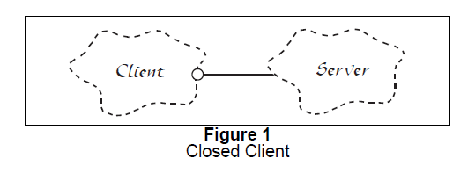
Figure 2 shows the corresponding design that conforms to the open-closed principle.
In this case, the AbstractServer class is an abstract class with pure-virtual member
functions. the Client class uses this abstraction. However objects of the Client class
will be using objects of the derivative Server class. If we want Client objects to use a
different server class, then a new derivative of the AbstractServer class can be created.
The Client class can remain unchanged.

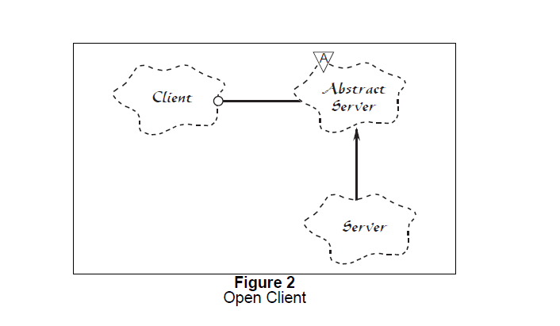

http://www.objectmentor.com/resources/articles/ocp.pdf

http://c2.com/cgi/wiki?OpenClosedPrinciple

2. Principiul Liskov al Substitutiei (LSP)

FUNCTIONS THAT USE POINTERS OR REFERENCES TO BASE
CLASSES MUST BE ABLE TO USE OBJECTS OF DERIVED CLASSES
WITHOUT KNOWING IT.
The above is a paraphrase of the Liskov Substitution Principle (LSP). Barbara Liskov first
wrote it as follows nearly 8 years ago1:
What is wanted here is something like the following substitution property: If
for each object o1 of type S there is an object o2 of type T such that for all
programs P

defined in terms of T, the behavior of P is unchanged when o1 is
substituted for o2 then S is a subtype of T.
The importance of this principle becomes obvious when you consider the consequences
of violating it. If there is a function which does not conform to the LSP, then that
function uses a pointer or reference to a base class, but must know about all the derivatives
of that base class. Such a function violates the Open-Closed principle because it must be
modified whenever a new derivative of the base class is created.

http://www.objectmentor.com/resources/articles/lsp.pdf

http://c2.com/cgi/wiki?LiskovSubstitutionPrinciple

3. Principiul dependentei inverse

http://www.objectmentor.com/resources/articles/dip.pdf
http://c2.com/cgi/wiki?DependencyInversionPrinciple

4. Principiul segregarii interfetei

This principle deals with the disadvantages of “fat” interfaces.
Classes that have “fat” interfaces are classes whose interfaces are not cohesive. In other
words, the interfaces of the class can be broken up into groups of member functions. Each
group serves a different set of clients. Thus some clients use one group of member functions,
and other clients use the other groups.
The ISP acknowledges that there are objects that require non-cohesive interfaces;
however it suggests that clients should not know about them as a single class. Instead, clients
should know about abstract base classes that have cohesive interfaces. Some languages
refer to these abstract base classes as “interfaces”, “protocols” or “signatures”.
In this article we will discuss the disadvantages of “fat” or “polluted” interfacse. We
will show how these interfaces get created, and how to design classes which hide them.
Finally we will present a case study in which the a “fat” interface naturally occurs, and we
will employ the ISP to correct it.

http://www.objectmentor.com/resources/articles/isp.pdf
http://c2.com/cgi/wiki?InterfaceSegregationPrinciple

5. Principiul echivalentei reutilizare / livrare (ERP)

http://c2.com/cgi/wiki?ReuseReleaseEquivalencePrinciple

6. Principiul reutilizarii comune ( CRP)

http://c2.com/cgi/wiki?CommonReusePrinciple

7. Principiul intretinerii comune (CCP)

http://c2.com/cgi/wiki?CommonClosurePrinciple

8. Principiul dependentei aciclice (ADP)

http://c2.com/cgi/wiki?AcyclicDependenciesPrinciple

9. Principiul dependentelor stabile (SDP)

http://c2.com/cgi/wiki?StableDependenciesPrinciple

10. Principiul abstractiunilor stabile (SAP)

http://www.objectmentor.com/resources/articles/stability.Pdf

http://www.ddj.com/architect/184415285

http://c2.com/cgi/wiki?StableAbstractionsPrinciple

11. Single Responsibilities Principle

http://c2.com/cgi/wiki?SingleResponsibilityPrinciple

12. Principiul optiunii unice

http://c2.com/cgi/wiki?SingleChoicePrinciple

13. Principiul ascunderii informatiei

http://c2.com/cgi/wiki?InformationHiding

